**VitalRise: Empowering your Healthcare Career**

1. **Introduction**

India has currently more than **2 lakh** qualified doctors who are unemployed and can be effectively deployed to improve the basic health services in the country. The study estimated (from National Health Workforce Account ) a total stock of **5.76** million health workers which included allopathic doctors (**1.16** million), nurses/midwives (**2.34** million), pharmacist (**1.20** million), dentists (**0.27** million), and traditional medical practitioner (**0.79** million). Stock density of doctor and nurses/midwives are **8.8** and **17.7**, respectively, per 10,000 persons as per NHWA. However, active health workers’ density (estimated from NSSO) of doctor and nurses/midwives are estimated to be **6.1** and **10.6**, respectively. The numbers further drop to **5.0** and **6.0**, respectively, after accounting for the adequate qualifications. However, the active health workforce size estimated is much lower (3.12 million) with allopathic doctors and nurses/midwives estimated as **0.80** million and **1.40** million, respectively.

Some [analysis](https://www.aha.org/fact-sheets/2021-11-01-data-brief-health-care-workforce-challenges-threaten-hospitals-ability-care)suggests that hospital employment has decreased by nearly **94,000** since the COVID-19 pandemic began, including a decrease of over **8,000** between August 2021 and September 2021 alone. This shortage is expected to last well into the future, with the demand for healthcare only expected to increase. Because of that, the healthcare industry is projected to add the most jobs of all industry sectors by 2030 at about [**3.3** million jobs](https://www.bls.gov/news.release/ecopro.nr0.htm).

By many estimates, the healthcare sector is poised to grow at a significant rate in the coming years. healthcare sector in India includes hospitals, medical devices, clinical trials, outsourcing, telemedicine, medical tourism, health insurance and medical equipment. Therefore developing the healthcare sector from a **jobs perspective**, will lead the growth in employment across such areas.

* 1. **Project Overview**

The purpose of our project is to develop a website that connects job seekers in the medical field with potential employers. The website will provide a platform for job seekers to create their profile, upload their education qualifications and skills, and search for relevant job openings. Employers will be able to post job openings, search for job seekers with specific qualifications and skills, and contact job seekers to schedule interviews.

The website have a user-friendly interface that make it easy for job seekers to navigate and find job openings. The website will also allow employers to post job openings and search for potential candidates based on their qualifications and skills. The system will enable employers to post job descriptions and requirements, review candidate profiles, and select the most suitable candidates.

The website also have a Chatbox feature which enables job seekers and employers to communicate with each other in real time, providing a faster and more efficient mode of communication, it will allow job seekers and employees to maintain their privacy, as they do not have to share their personal contact information, such as phone number or email address, with employers or HR representatives.

* 1. **Project Objectives**

As there is shortage of employees in medical sector & there are large no. of skilled people who are unemployed, so the main objective of this project is to create a platform that can connect job seekers in the medical field with potential employers. The website will make it easier for job seekers to find job openings that match their education qualifications and skills, while also providing employers with a larger pool of qualified job seekers to choose from.

The main objective of the website is to serve as a platform that connects unemployed individuals and skilled medical professionals with relevant job opportunities in the medical field. The website will use a database of job listings from hospitals, clinics, nursing homes, and other medical institutions to match job seekers with suitable job openings based on their profile, education qualification, and skills.

The website will offer the following features:

1. Job Listings: The website will display job listings from various medical institutions, including hospitals, clinics, nursing homes, and other healthcare facilities.
2. User Profiles: Job seekers can create user profiles that showcase their education qualifications, work experience, and skills.
3. Job Matching: The website will use a matching algorithm to connect job seekers with relevant job openings based on their user profile.
4. Job Applications: Job seekers can apply for jobs directly through the website by submitting their resume and cover letter.
5. Employer Profiles: The website will also allow employers to create profiles that showcase their medical institution, job openings, and hiring criteria.
6. Communication: The website will enable job seekers and employers to communicate directly through the platform, facilitating the hiring process.
   1. **Project Scope**

The project scope for the project is to provides job opportunities in the medical field is quite vast. This website is intended to cater to the needs of job seekers looking for employment opportunities in the healthcare industry. The main focus of this website is to make it easier for healthcare professionals to find jobs that suit their qualifications, skills, and experience.

* + The scope of the project includes creating a user-friendly website that is easy to navigate and use. The website must have a well-designed user interface that allows job seekers to search and apply for jobs, create profiles, upload resumes, and track their job applications. The website must also provide employers with a platform to post job listings, search resumes, and contact job seekers.
  + The website must be designed to accommodate various types of healthcare jobs, including positions in hospitals, clinics, nursing homes, and other healthcare facilities. It must allow job seekers to search for jobs based on location, job title, experience, and other criteria.

Another important aspect of the project scope is to create a platform for employers to screen and evaluate candidates. Employers should be able to view candidate profiles and resumes and contact them directly if they are interested in their qualifications. The website must also provide employers with tools to manage their job postings, track applications, and communicate with job seekers

* 1. **Target Beneficiary**

The target beneficiaries of this project includes-:

1. Job Seekers: This includes individuals who are interested in pursuing a career in the medical field, such as doctors, nurses, pharmacists, lab technicians, and administrative staff. They will be able to create their profiles on the website, upload their resumes and apply for relevant job openings.
2. Employers: This includes healthcare institutions such as hospitals, clinics, nursing homes, and diagnostic centers, which are looking to recruit qualified and skilled professionals for their organizations. Employers will be able to post job openings, search for candidates based on their qualifications and experience, and communicate with potential candidates.
3. Recruiters: This includes recruitment agencies that specialize in placing candidates in the healthcare sector. They will be able to use the website as a platform to find suitable candidates for their clients.
4. Educational Institutions: This includes universities and colleges that offer medical courses and programs. They can use the website to promote their programs and connect with potential candidates who are interested in pursuing a career in the medical field.
5. Healthcare Industry Associations: This includes professional organizations and associations in the healthcare industry, which can use the website to promote their services and connect with potential members and client.
   1. **Unique Selling Point**

Here are some key aspects that could be highlighted as the website's USP:

* **Specialized job search:** The website could offer a highly targeted and specific job search that is focused solely on healthcare jobs. This could include jobs in hospitals, clinics, nursing homes, and other healthcare facilities. This means that job seekers can easily find job openings that match their qualifications and interests, without having to sift through irrelevant job listings.
* **Profile-based job matching:** The website could use a sophisticated algorithm to match job seekers with the right job openings based on their profile, education qualifications, skills, and experience. This means that job seekers could receive customized job recommendations that are tailored to their unique strengths and preferences.
* **Comprehensive job listings:** The website could provide a comprehensive listing of job opportunities in the healthcare industry. This could include job openings for a variety of roles such as doctors, nurses, technicians, administrators, and support staff. This means that job seekers could easily find job openings that match their skills and interests.
* **Employer branding:** The website could also help healthcare employers build their brand and attract top talent by showcasing their culture, values, and work environment. This means that job seekers could gain insights into the healthcare employers they are interested in working for, and make informed decisions about their career paths

1. **Project Description**
   1. **Project Perspective**

The perspective of this project is to develop a platform that can connect job seekers in the medical field with potential employers such as hospitals, clinics, nursing homes, and doctors. The platform will provide a user-friendly interface for job seekers to create their profile and showcase their education qualifications, skills, and experience. The platform will also provide job listings and notifications to help job seekers stay up-to-date with job opportunities. Employers can post job openings and browse through the profiles of potential candidates to find the right fit for their organization. The goal of this project is to provide a streamlined and efficient process for job seekers and employers to find the right match.

Overall, the project perspective should aim to create a platform that fosters collaboration between healthcare professionals and healthcare institutions and helps to address the staffing needs of the healthcare industry.

* 1. **Project Functions**

The Project function for our website that aimed at providing jobs in the medical field include:

* User registration and login- This function allows job seeker to create an account on the website by providing their basic details such as name, email address, phone number, and password. The registration process may also require users to verify their email address or phone number before they can log in to their account. Once registered, users can log in to their account using their email address or phone number and password.
* User profile creation and management- After successful registration, users will be directed to create their profiles. The profile will include details such as personal information, education qualification, professional experience, skills, certifications, etc. The users will be able to update their profiles and add more information as they gain more experience or education. The profile will be visible to potential employers who can search for suitable candidates based on their qualifications and experience.
* Job search and application- The website will have a search engine that will allow job seekers to search for jobs based on their preferences such as location, job title, job type, and other criteria. The search results will be displayed based on the user's preferences and the availability of jobs that match the search criteria. The website will also provide job alerts to users via email or notifications for new job postings that match their skills and experience. Users will be able to apply to jobs directly through the website by submitting their resumes and other relevant documents.
* Employer dashboard for job posting and candidate search - The website will provide an employer dashboard for employers to post job vacancies and search for suitable candidates. Employers will be required to create an account and provide their company information. The employer dashboard will allow employers to create job postings, manage job postings, view resumes of candidates who have applied for their job postings, and communicate with candidates through the website.
* Notifications for new job postings and applications- The website will send notifications to users who have subscribed to job alerts for new job postings that match their skills and experience. The website will also notify employers when new candidates have applied for their job postings. Notifications will be sent via email or through the website's notification system
  1. **User Classes**

The website will have two main user classes: job seekers and employers. Job seekers will be able to create a profile, search for job openings, and apply for jobs. Employers will be able to post job openings, search for job seekers with specific qualifications and skills, and contact job seekers to schedule interviews.

1. **Job Seekers**: This class of users includes those individuals who are looking for job opportunities in the medical field. They may have varying levels of education and experience, and are seeking job opportunities that match their skills and qualifications. The job seeker user class can be further broken down into the following sub-categories:

* **Fresh Graduates:** These are individuals who have recently completed their education in the medical field and are looking for entry-level jobs to start their career.
* **Experienced Professionals:** This category includes individuals who have some experience working in the medical field and are looking for job opportunities that match their skills and experience.
* **Freelancers:** Some individuals may be looking for freelance opportunities in the medical field, such as freelance nurses or doctors who can work on a per-project basis.

1. **Employers**: This class of users includes organizations that are looking to hire medical professionals for their hospitals, clinics, nursing homes, or other medical facilities. Employers may have varying requirements when it comes to the education and experience of the candidates they are looking to hire. The employer user class can be further broken down into the following sub-categories:

* **Hospitals:** These are organizations that run hospitals and are looking to hire medical professionals such as doctors, nurses, and other healthcare staff.
* **Clinics:** These are organizations that run clinics and are looking to hire medical professionals such as doctors, nurses, and other healthcare staff.
* **Nursing Homes:** These are organizations that run nursing homes and are looking to hire medical professionals such as nurses, caregivers, and other healthcare staff.
* **Doctors:** These are individual doctors who are looking to hire medical professionals for their private practice. They may be looking for nurses, medical assistants, or other healthcare staff.

Top of Form

* 1. **Design Implementation & Constraints**
* **Programming Language: JavaScript**

We used JavaScript as a programming language in our website to create dynamic and interactive web pages. We have used Javascript to create animations, dynamic menus, and other interactive features.

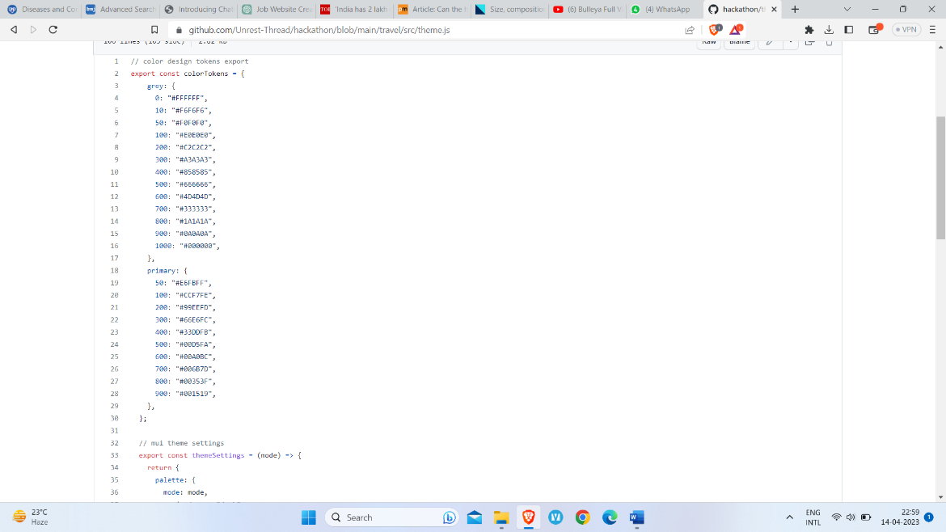

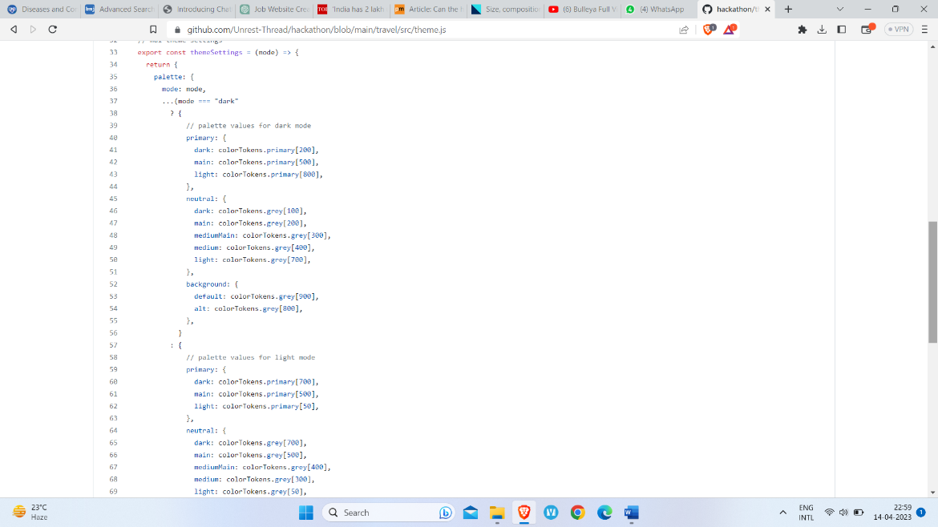

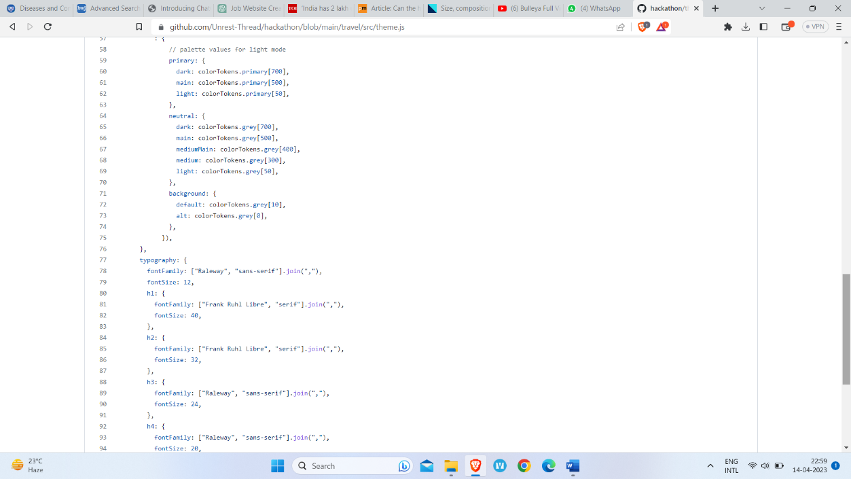

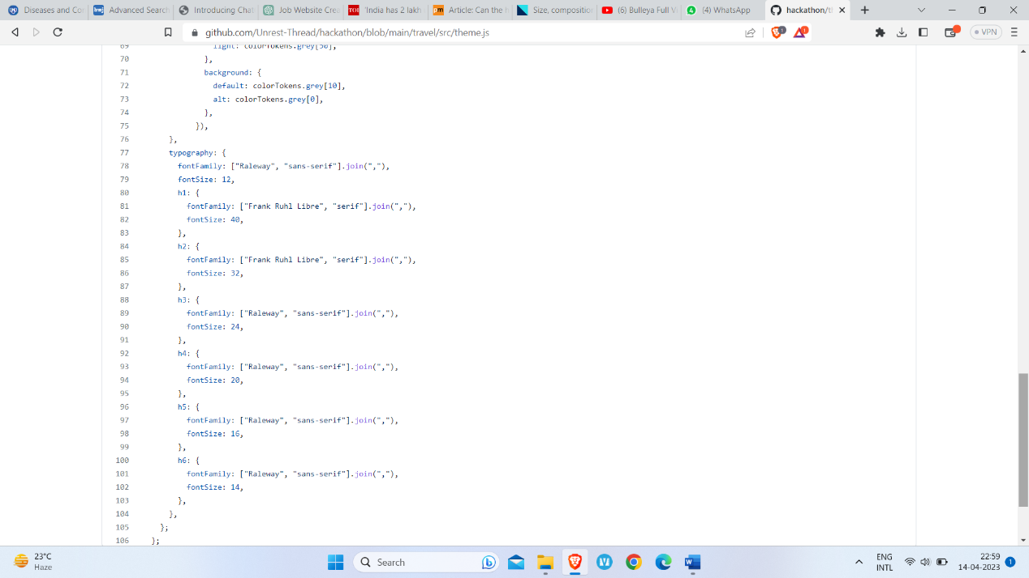

* **Web Framework: Node.js**

The backend of our website is developed on Node.js framework which is a popular server-side JavaScript runtime that is used for building scalable web applications. Through node.js, we’re able to provide messaging feature in our website.

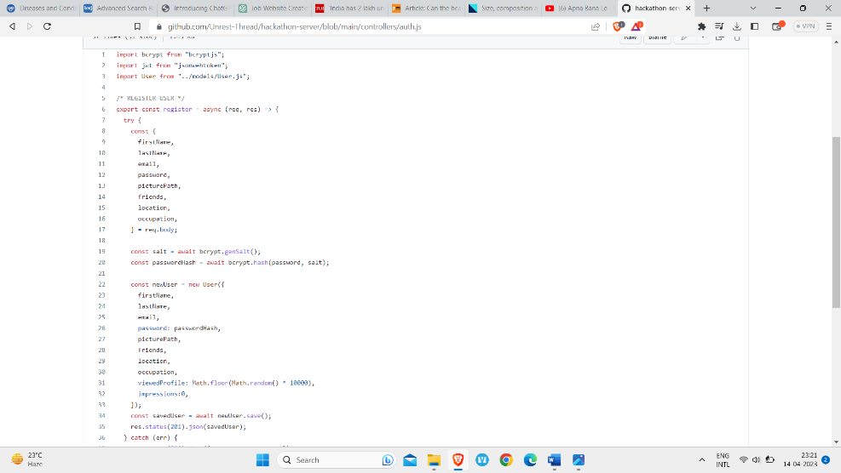

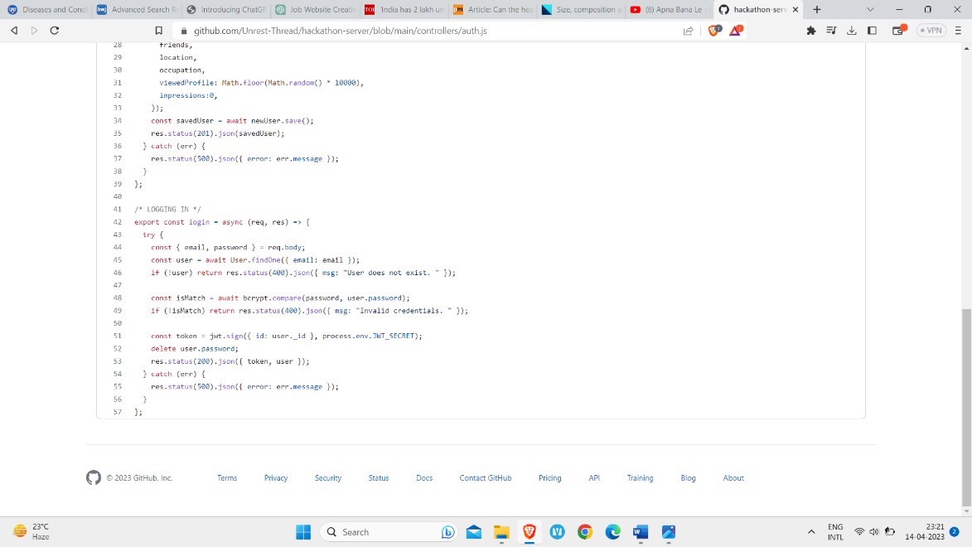

* **Database: MongoDB**

The Job seekers data which includes name, email id, qualification, experience etc and employers data which include organization name, no. of vacancies or any other type of unstructured massive amount of data that will be used in our website will get stored in the MongoDB database.

We used MongoDB as it is a scalable and flexible database that is well-suited for web applications that require high-performance data storage and retrieval.

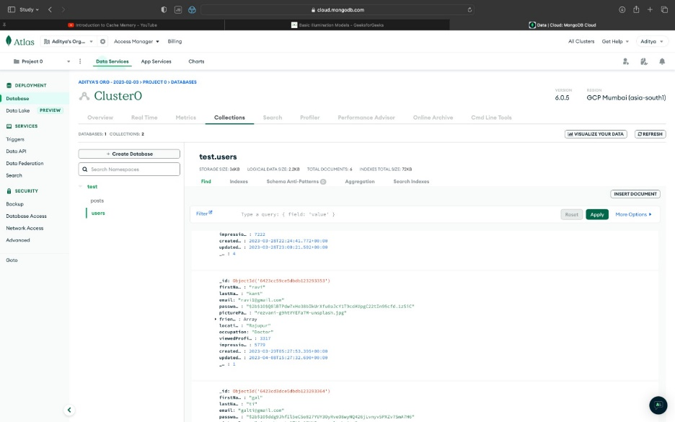

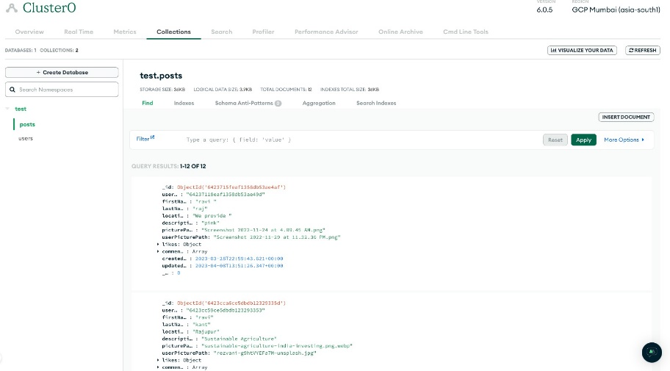

* **Frontend Framework: React.js**

We used React.js framework for building user interfaces of our website. It is a component-based library that allows us to create reusable UI components that can be used across multiple applications.

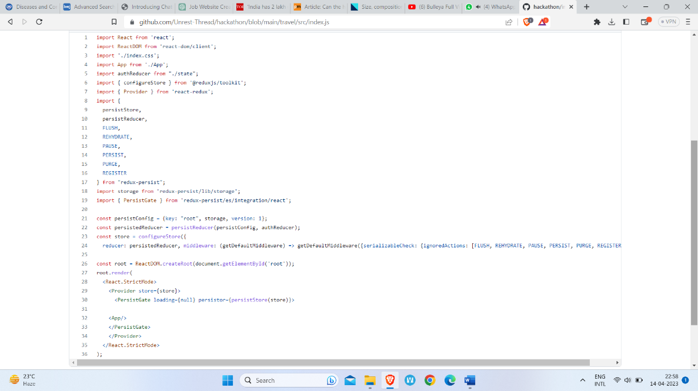

* **Server: Google Cloud**

We have deployed our project on google cloud and also used its AMD instances while deploying it.

The use of **AMD instances** in our website helps us to optimize the website's performance, speed, and processing capabilities. The use of cloud and AMD instances in the job portal of our website helps us to ensure that the platform is reliable, efficient, and capable of handling the demands of a large user base.

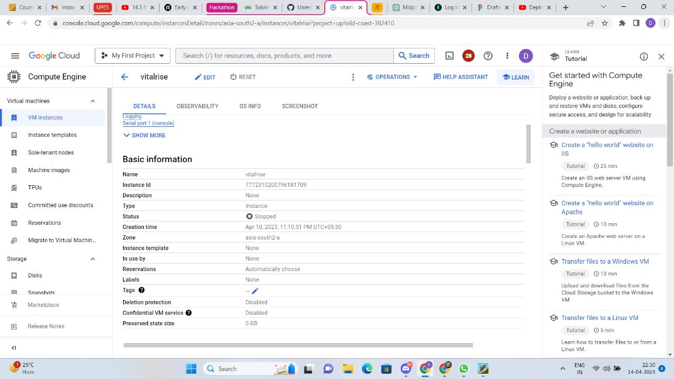

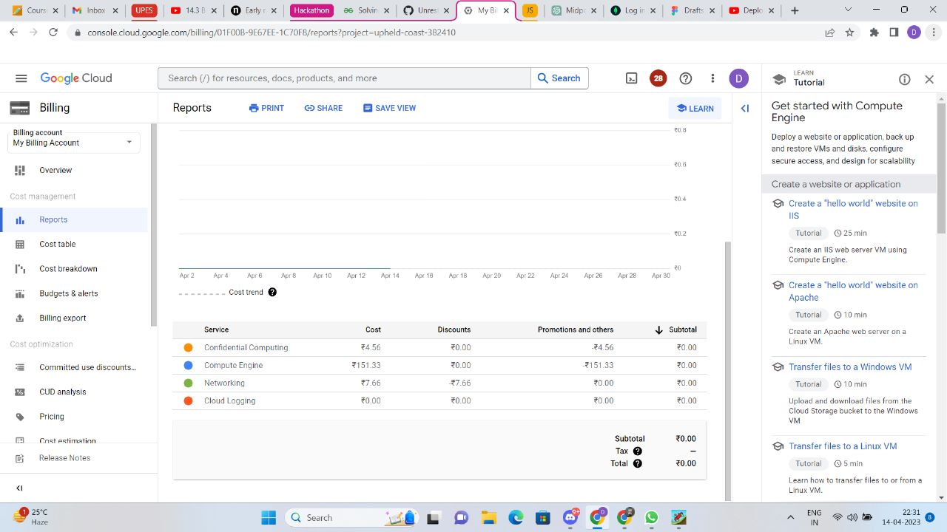

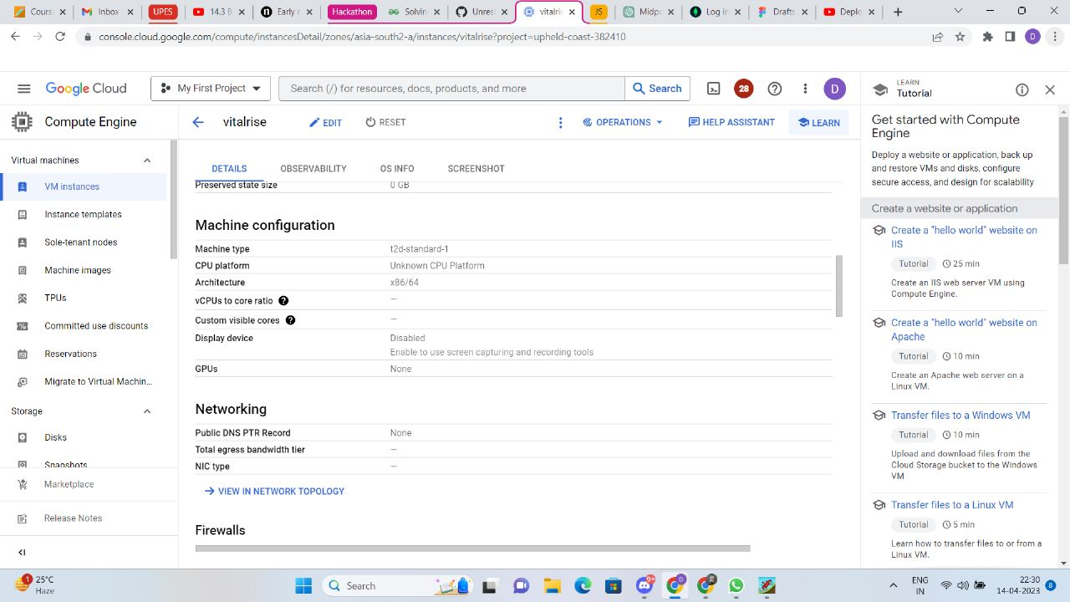

We’ve created different repositories of Frontend and Backend of our project in Github to show their files in a systematic manner.

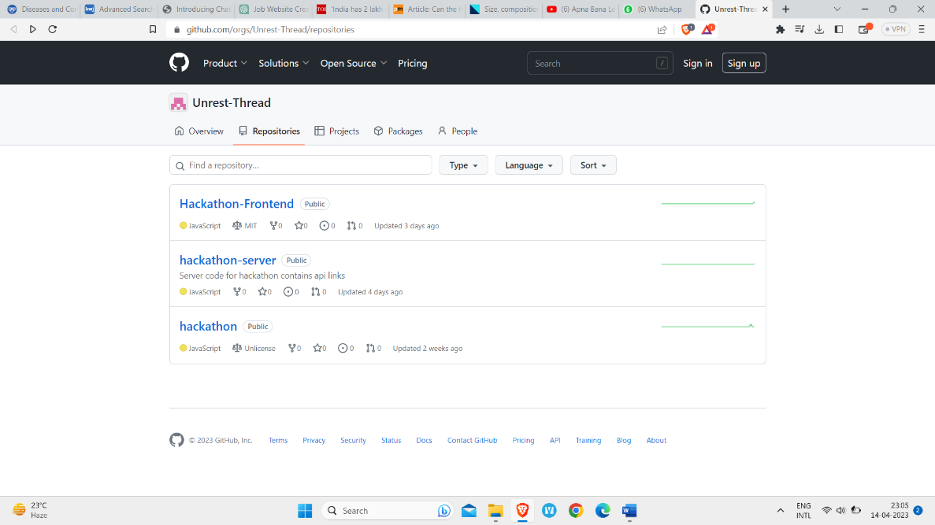

**Frontend**

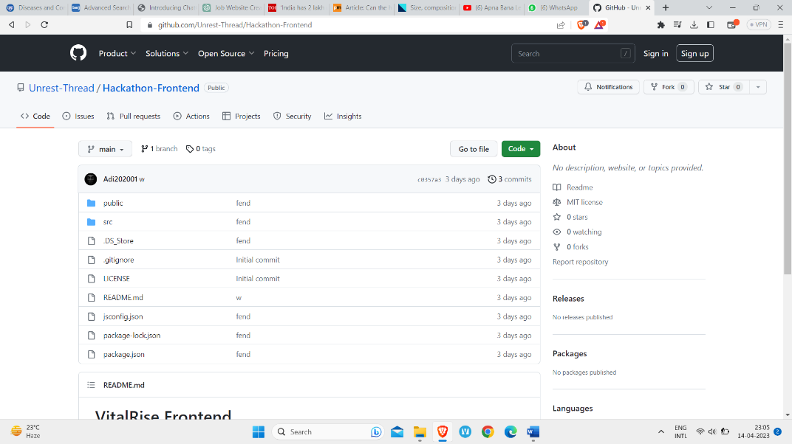

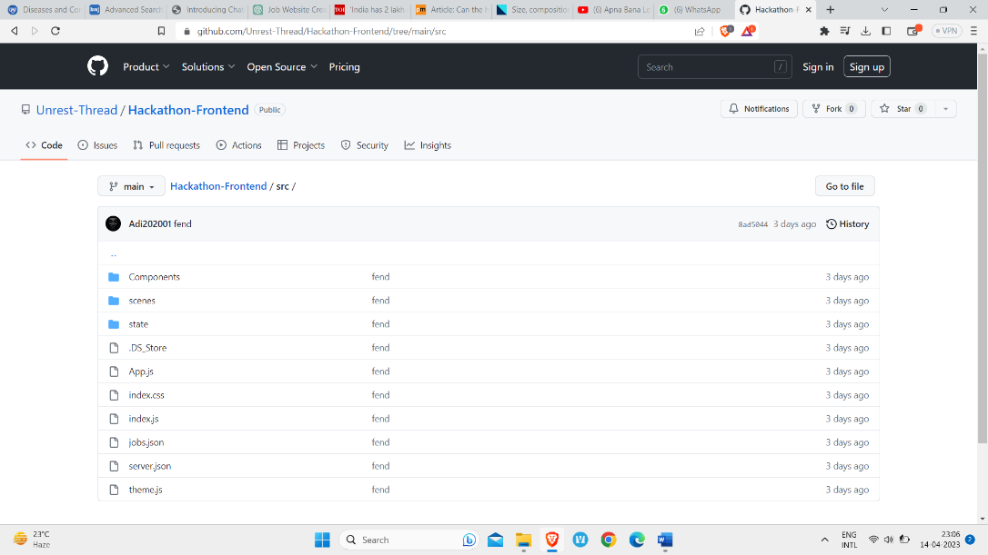

**Server**

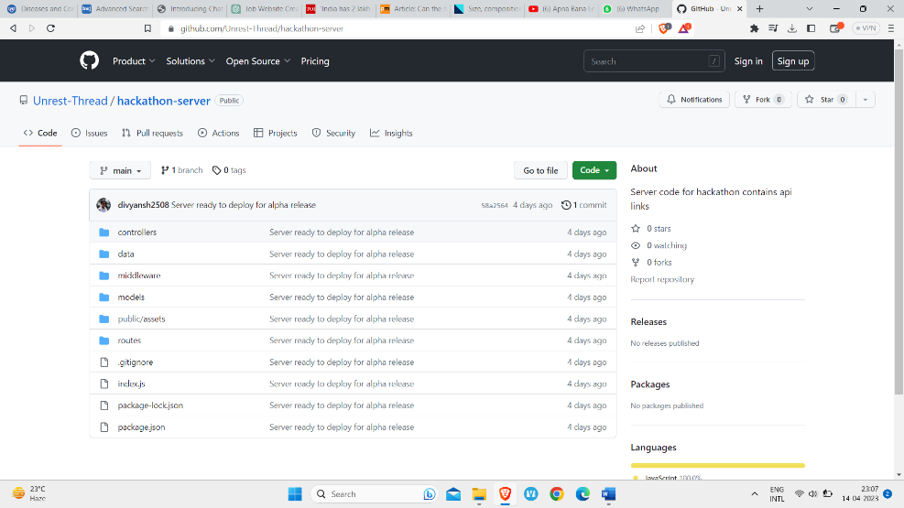

* 1. **Assumptions & Dependencies**

The following assumptions and dependencies have been made in the development of this project:

**Assumptions:**

1. Users have a basic understanding of how to navigate and use a website.
2. Users will provide accurate and truthful information in their profiles.
3. The website will comply with all applicable laws and regulations.
4. The website will be accessible to users with disabilities.
5. The website will be available 24/7 with minimal downtime for maintenance.
6. Users will have access to reliable internet and device.
7. The website will be hosted on a secure server to protect user data.

**Dependencies:**

1. The availability and reliability of third-party payment gateway services for processing payments for premium services and job posting credits.
2. The availability and reliability of the Google Cloud server to host the website.
3. The availability and reliability of MongoDB for database management.
4. The ability to integrate job feeds and job posting from different sources to the website.
5. Compliance with laws and regulations related to the medical field and employment.
6. The availability of skilled developers and designers to develop and maintain the website.
7. The website's success depends on the number of job seekers and employers who use the website.
8. **User Interface**

The following given are the wireframes of our website’s different-:

1. **Home Page Wireframe**

This is the basic home page layout with variable card and compact layout to suit the user’s needs

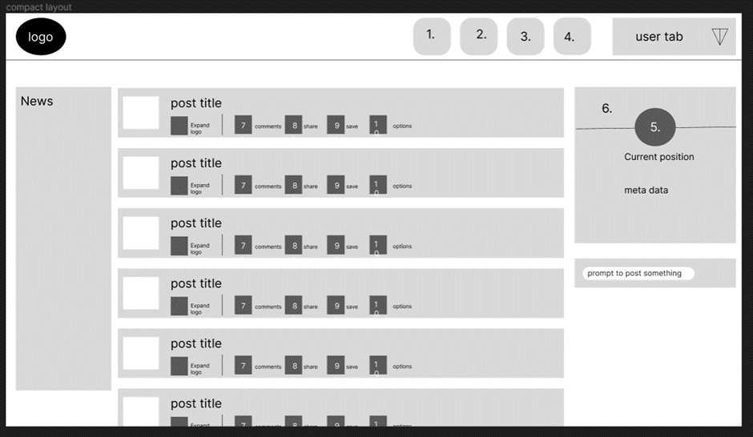

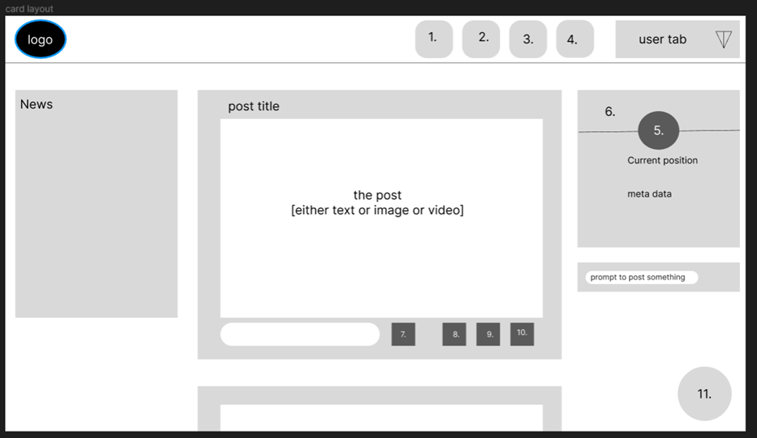

The numbers given in the above wireframe images depicts the following functions-:

1. Home: This is the landing page of the website, where users can view featured job listings, search for jobs by keywords, location, and other criteria, and access their account information and saved job searches.
2. Contacts: This page contains the profiles of your connections as well as links to the website's social media accounts.
3. Jobs: This page displays a list of job listings, along with basic information such as job title, location, and employer. Users can filter the job listings based on their preferences, such as job type, location, and experience level.
4. Messaging: This feature allows users to send messages to other users, such as employers or other job seekers. This can be used for networking or for communicating about job opportunities.
5. Profile Picture: This is the user's profile picture, which is displayed on their profile page and on any messages or comments they post.
6. Banner Image: This is a large, visually striking image that appears at the top of the website's homepage. It can be used to showcase featured job listings or to highlight other important information about the website or the medical field.
7. Comments: This feature allows users to leave comments on job listings or other content on the website. This can be used to share feedback or ask questions about specific job opportunities.
8. Share: This feature allows users to share job listings or other content on social media or via email. This can be used to spread the word about job opportunities to a wider audience.
9. Save: This feature allows users to save job listings or other content to their account, so they can easily access it later or be notified of updates or changes.
10. Options: This feature provides users with additional options for customizing their job search, such as setting up job alerts or creating a custom job search filter.
11. **Profile Page Wireframe**

The Following is the wireframe of the Profile Page.

The activity is where the user’s posts, comments and saved data is found.

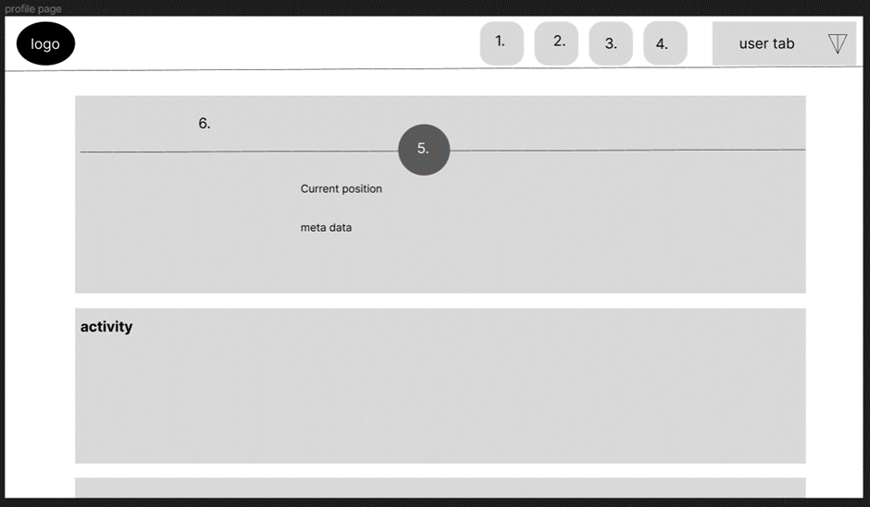

1. **Chatroom wireframe**

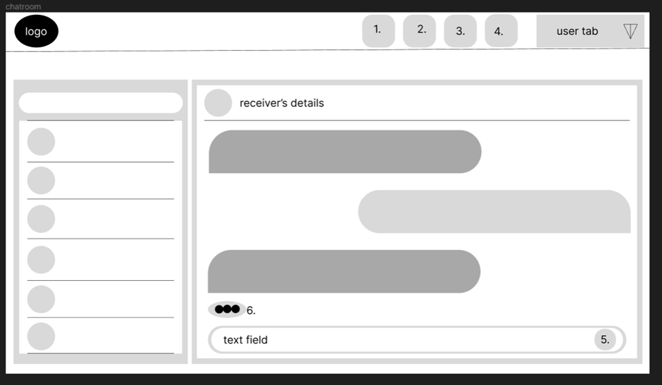

The numbers given in the above wireframe images depicts the following functions:

5. options to add images, videos, links etc

6. will show up when the other person is typing something

1. **Login Portal Wireframe**

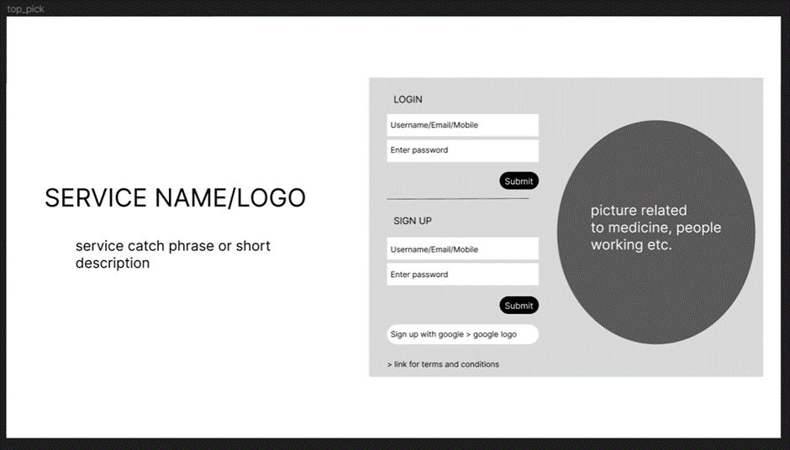

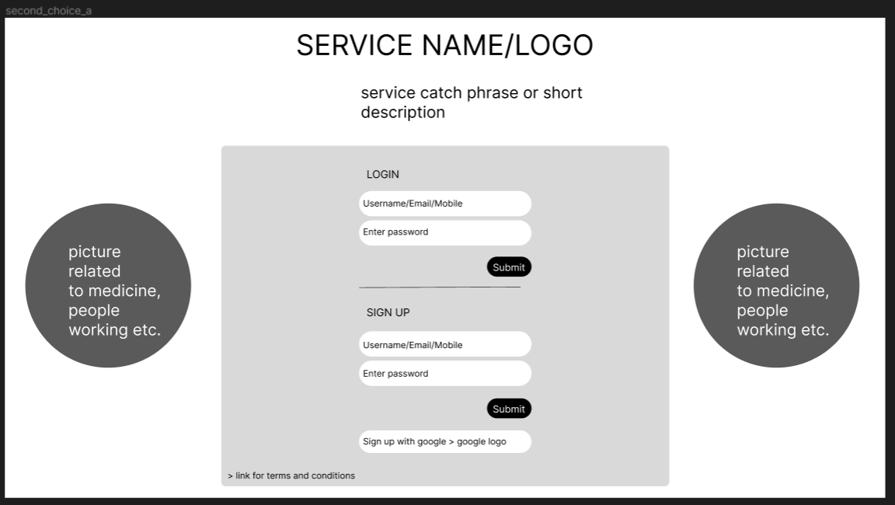

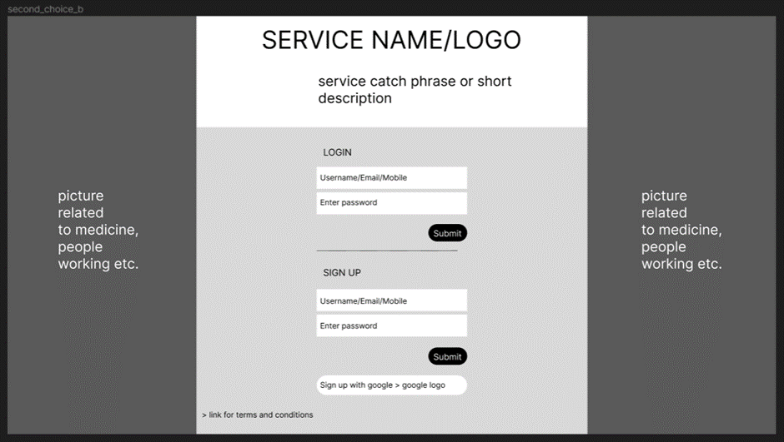

The above three images are the alternative wireframes ideas we designed for the login page

1. **Job Page Wireframe**

The job page of the website will be designed to provide a user-friendly interface for job seekers to search and apply for relevant job opportunities in the medical field. The job page will be accessible from the website's main menu and will prominently feature a search panel that will allow users to search for jobs based on their preferences, such as job type, location, and salary range.

The search panel will have auto-suggestions that will help users in refining their search criteria. For example, if a user types "nurse" in the search bar, the search panel will suggest related job titles such as "registered nurse," "licensed practical nurse," and "nursing assistant." Below the search panel, there will be a list of open job listings that match the user's search criteria. The job listings will be displayed in a grid format, with each listing displaying the job title, location, employer name, and a brief description of the job responsibilities.

Here one will first notice the big search panel with suggestions. If the user is not sure as to what he wants to search, he may use one of the suggestions or he may simply check the relevant open jobs listed below.

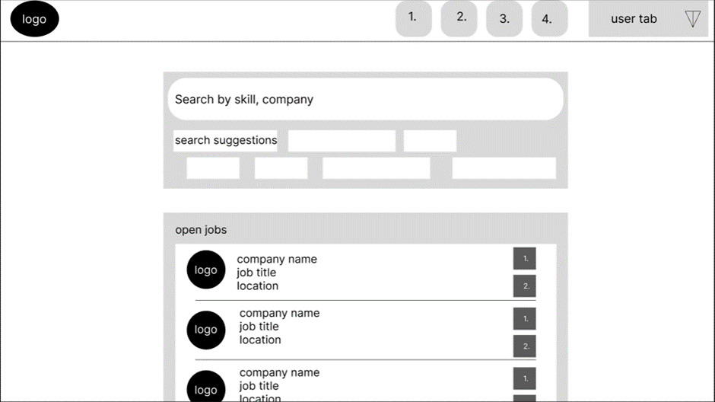

1. **Research Page Wireframe**

This page we haven’t developed or implemented in our initial phase of our project but will develop this page in the next phase of the project. The Research Page will help the medical students by not only search about the diseases & its causes & prevention but also help students or medical professionals who want to read any research paper related to any disease or vaccine or any innovation in medical field.

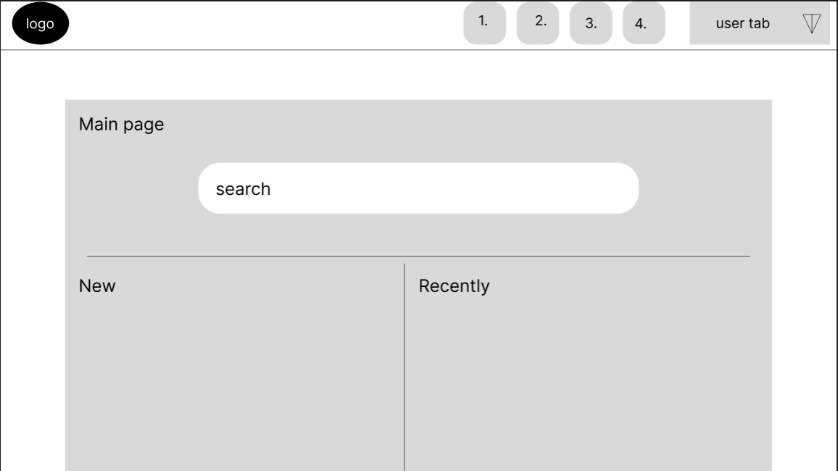

1. **Research Home Page**

Specific research documentation page

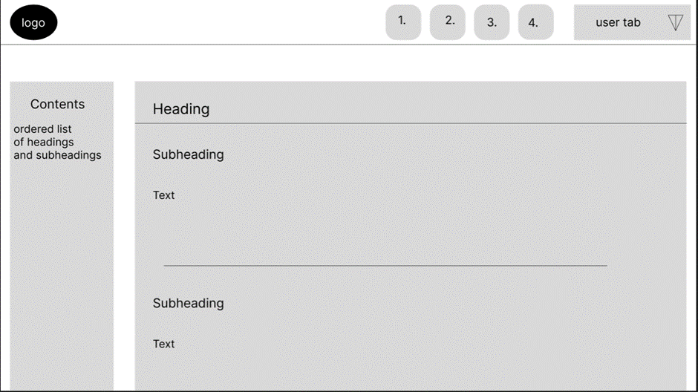

**3.1 Design Constraints**

The Resolution used in the UI/UX design of our project is 1920 × 1080

* **Colour Palettes**

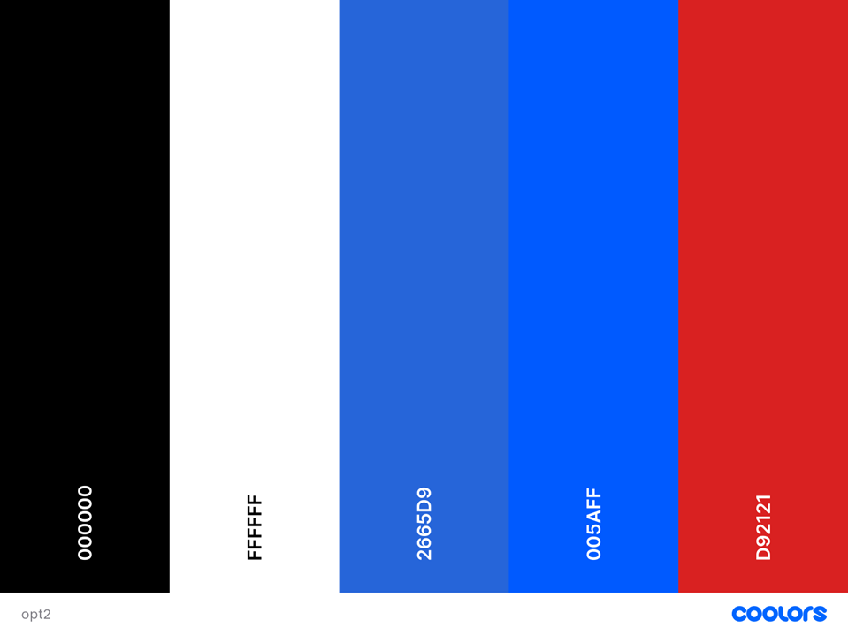

Standard formal color pallete. White and black can provide a classic contrast that is easy to read and navigate, while blue can be used to highlight important or clickable elements. Red can be used sparingly for alerts or notifications to draw attention to critical information.

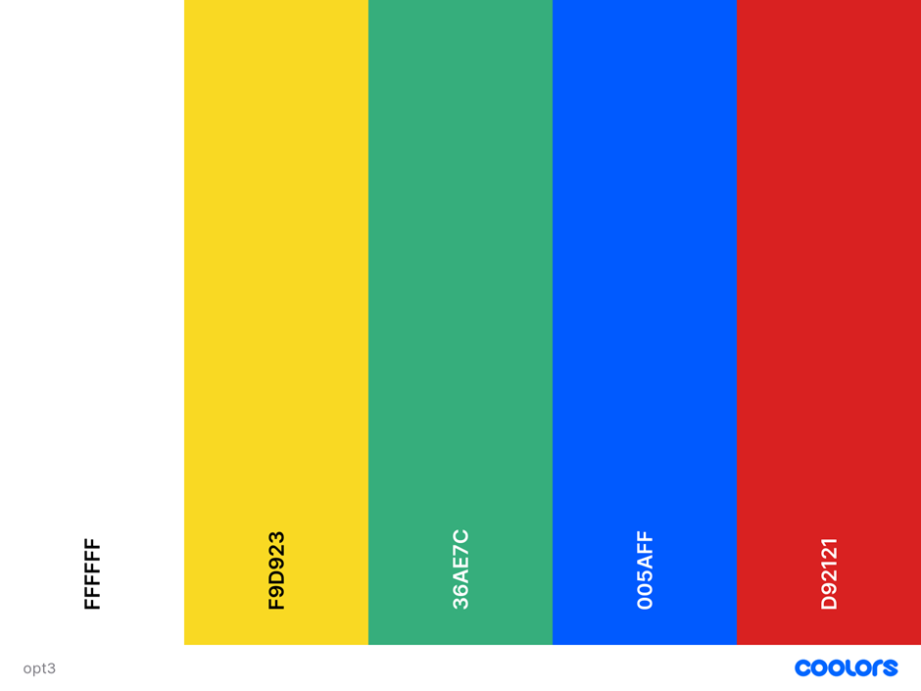

For creating a colorful palette for a chat room or user profiles, we consider the following:

* Using a light background color for the main content area, such as a light grey or pastel blue.
* Using white or light grey for text to ensure readability.
* For accents, use a bright and cheerful color such as yellow or green to highlight important areas or call-to-action buttons.
* Using blue sparingly for important fields or links to create a sense of trustworthiness and stability.
* Using red sparingly for alerts or warnings to ensure they stand out and grab the user's attention.

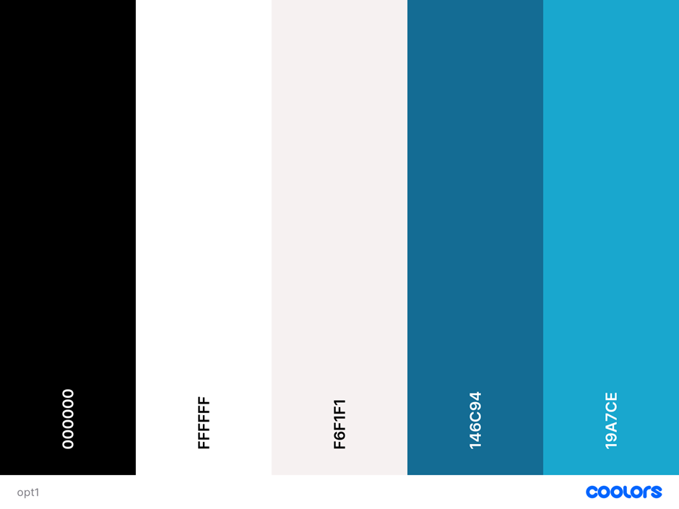

We decided black and white contrast with varying shades of blue colour palette for our website’s homepage which will look strict

* Home page: The main color of the home page could be white with black text, and shades of blue could be used for accents such as buttons, links, and headings.
* Navigation menu: The navigation menu could be black with white text, and when a menu item is selected, the text could change to a shade of blue to indicate the active page.
* Footer: The footer could also be black with white text, and a lighter shade of blue could be used for links.

3.2 **Website’s Logo**



After several rounds of ideation and brainstorming this is the logo we came up with. It shows the medical field and how we are bringing people together for the betterment of doctors and the medical field as a whole**.**

3.3 **Job Seeker UI**

* User-friendly interface for creating and managing profiles
* Easy-to-use search function for finding relevant job openings
* Clear and concise job descriptions with required qualifications and skills
* Simple and intuitive application process

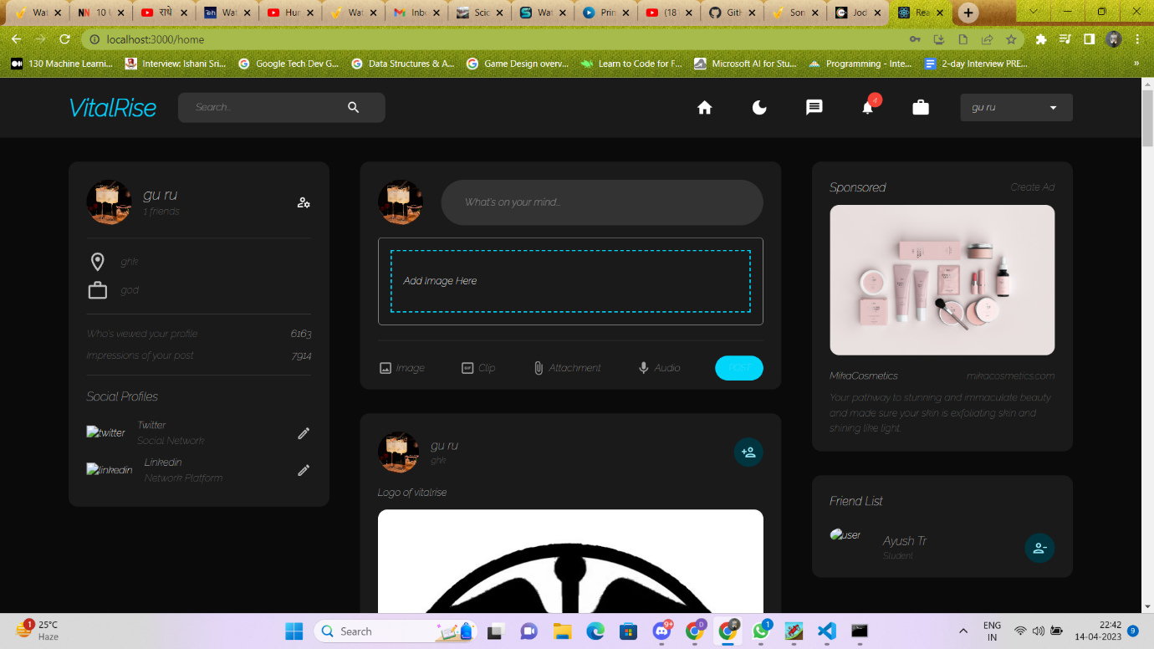

**3.4 Employer UI**

* User-friendly dashboard for creating and managing job postings
* Easy-to-use search function for finding qualified job seekers
* Clear and concise candidate profiles with required qualifications and skills
* Simple and intuitive communication system for contacting job seekers

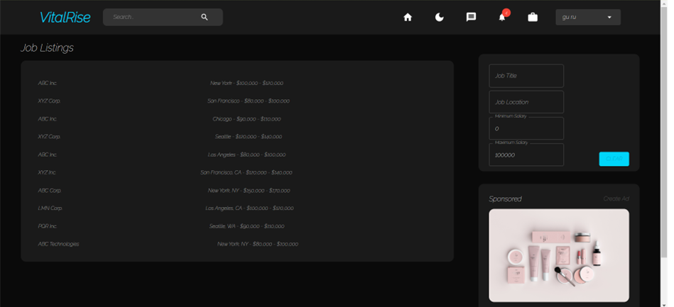

**4. Functional Requirements**

**4.1 User Registration**

* Users should be able to create a new account by providing their name, email address, and password.
* The system should validate the email address and password strength.
* The user should receive a confirmation email to activate their account.

**4.2 User Login**

* Users should be able to log in to the system using their email and password.
* The system should validate the user's credentials and redirect them to their dashboard.

**4.3 User Profile**

* Users should be able to create and manage their profile, including their education qualifications, work experience, and skills.
* Users should be able to upload their resume and cover letter in a PDF format.
* Users should be able to set their privacy settings to control who can view their profile.

**4.4 Job Search**

* Users should be able to search for job openings based on location, job title, and job type.
* Users should be able to view job details such as the job description, qualifications, and application deadline.
* Users should be able to apply for a job by submitting their resume and cover letter.

**4.5 Employer Dashboard**

* Employers should be able to create and manage job postings.
* Employers should be able to search for job seekers based on location, education qualifications, and skills.
* Employers should be able to view job seeker profiles and contact them to schedule interviews.

**4.6 Job Application Tracking**

* Users should be able to track the status of their job applications, including whether their application has been viewed or rejected by the employer.
* Employers should be able to manage their job postings and track the status of job applications.

**4.7 Notifications**

* Users should receive notifications when new job postings that match their qualifications are posted.
* Employers should receive notifications when new job applications are submitted.

1. Non-functional Requirements 4.1 Performance

* The website should be able to handle a large number of concurrent users without slowing down.
* The website should have a response time of less than 3 seconds.

1. **Hardware Interface:**

The website will require the following hardware:

* Desktop or laptop computer with a modern web browser
* Internet connection

1. **Software Interface**

The website will interact with the following software systems:

* Web browser (Chrome, Firefox, Safari, etc.)
* Operating System (Windows, MacOS, Linux, etc.)
* Web server (Apache, IIS, etc.)
* Database server (MongoDB.)
* Email service (Amazon SES, SendGrid, etc.)

1. **Communication Interface**

The website will use HTTP/HTTPS protocols for communication between the client and the server. Email notifications will be sent using SMTP protocols.

1. **Non-Functional Requirements**

**7.1** **System Features**

Here are some system features that our website offers:

1. User Registration and Login: Users can register for an account and login to the system to access their profile and job search functions.
2. User Profile Creation and Management: Users can create and manage their profile by adding their education, skills, work experience, and other relevant information. They can also upload a profile picture and banner image.
3. Job Search and Application: Users can search for jobs based on their location, job category, and other search criteria. They can also apply for jobs through the website and track their application status.
4. Employer Dashboard for Job Posting and Candidate Search: Employers can post job openings and search for qualified candidates based on their job requirements. They can also manage their job postings and candidate applications through the employer dashboard.
5. Notifications for New Job Postings and Applications: Users can receive notifications via email or in-app notifications for new job postings and updates on their job applications.
6. Messaging: Users can communicate with employers and other users through a messaging system within the website.
7. Comments: Users can leave comments on job postings and employer profiles.
8. Share: Users can share job postings and employer profiles on social media platforms or through email.
9. Save: Users can save job postings and employer profiles for future reference.
10. Options: Users can customize their search options and preferences, such as the type of job alerts they want to receive.
11. **Software Quality Attributes**:
12. Maintainability: The website is designed to be easy to maintain, with clear and modular code that can be easily modified or updated.
13. Testability: The website is designed to be easily testable, with automated testing tools and processes in place to ensure quality and reliability.
14. Portability: The website is designed to be easily portable across different platforms and environment.
15. **Future Scope**

The future scope of the website has the potential to revolutionize the healthcare industry by not only providing job opportunities to aspiring medical professionals but also offering valuable resources such as a research page and chatbot.

* **Research:** The research page can provide a wealth of information for medical students and professionals seeking to learn more about diseases, causes, prevention, and medical innovations. This page could include resources such as peer-reviewed research articles, scholarly journals, medical textbooks, and other educational materials. By providing a centralized platform for healthcare professionals to access up-to-date and accurate medical information, the website can enhance the knowledge and expertise of the healthcare workforce.
* **Chatbot:** The chatbot can offer personalized assistance to users, providing quick and reliable answers to questions related to healthcare and medical research. By leveraging artificial intelligence and machine learning, the chatbot can learn from user interactions and improve its responses over time, making it an invaluable resource for medical professionals and students seeking on-demand support.
* **Refine Jobpage:** Refining the job page can help job seekers find the right job based on their qualifications and skills. By analyzing a user's previous work history and education, the job page can suggest jobs that align with their career goals and aspirations.